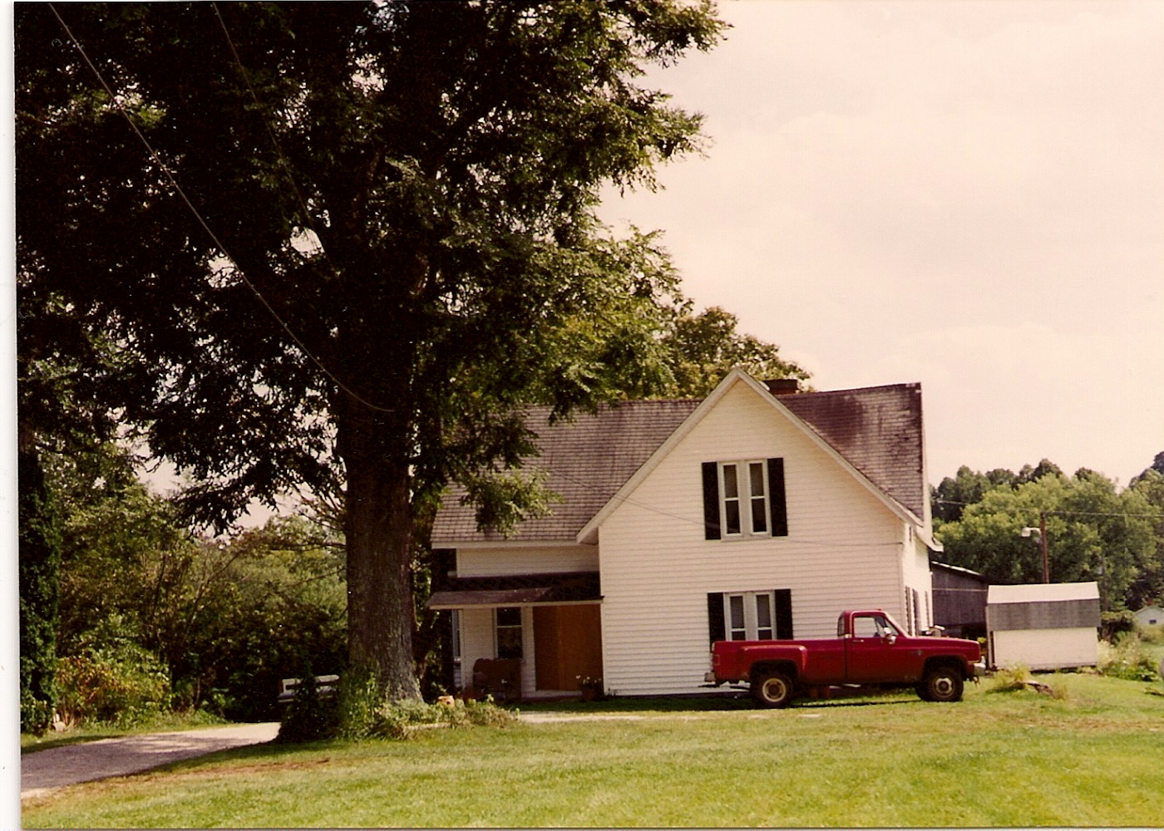
This picture found on Ancestry dot com: rushes85 originally shared this to Venoy Family Tree
16 Jul 2010
Under the siding on this house is a log cabin built by Andrew Supplee Hatfield who is an ancestor on my Hatfield tree. After Andrew it belonged to Oscar Mathers family. It later belonged to my ancestors on Farley tree, Burl Farley, then to his daughter Mollie Farley Cabell May. It was sold for the logs and stones to be used in Heritage Village in Huntington, WV. My mother, Georgia May Venoy, grew up in this house. Before demolition it was the oldest house in Cabell County, WV

